## **INDEX**

|  |  |  |
| --- | --- | --- |
| **S. NO.** | **CHAPTER NAME** | **PAGE NO.** |
| 1 | Introduction | 7 |
| 2 | Problem Statement | 9 |
| 3 | Present Investigation | 11 |
| 4 | **Software requirements specification (SRS)** | 12 |
| 5 | **Cost and effort estimation** | 16 |
| 6 | UML Class Diagram | 20 |
| 7 | Entity Relationship (E-R) Diagram | 23 |
| 8 | **Interaction diagram (sequence diagram)** | 26 |
| 9 | Description of different input validations and checks | 29 |
| 10 | Description of different reports | 31 |
| 11 | Sample test cases | 35 |
| 12 | Snapshots of different input and output screens (Result) | 39 |
| 13 | Conclusion | 44 |
| 14 | Limitation | 46 |
| 15 | Future Scope | 48 |
| 16 | Bibliography | 50 |
| 17 | Plagirism Report | 51 |

**LIST OF TABLES**

|  |  |  |
| --- | --- | --- |
| **TABLE S. NO.** | **DESCRIPTION** | **PAGE NO.** |
| 1 | Use Case Specification Table | 13 |
| 2 | Phase-Wise Effort Allocation Table | 16 |
| 3 | System’s major components (Key Classes) Table | 18 |
| 4 | ER Diagram’s Relationships Table | 22 |
| 5 | Sequence of Interactions Table | 24 |
| 6 | Input Validation Mechanisms Table | 27 |
| 7 | Error Handling Example Table | 28 |
| 8 | Output Report Formats and Tools Used Table | 30 |
| 9 | Sample Test Cases Table | 34 |

**LIST OF FIGURES**

|  |  |  |
| --- | --- | --- |
| **FIGURE S. NO.** | **DESCRIPTION** | **PAGE NO.** |
| 1 | UML Use Case Diagram | 12 |
| 2 | Work Breakdown Structure (Effort Distribution) | 17 |
| 3 | UML Class Diagram | 20 |
| 4 | Entity Relationship Diagram for Energy Consumption Prediction | 23 |
| 5 | Interaction Diagram (Sequemce Diagram) | 26 |
| 6 | Control Flow Graph | 33 |

## **Chapter 1 : INTRODUCTION**

The continuous rise in electricity demand, energy costs, and carbon emissions has made efficient energy consumption more critical than ever. In residential settings, most users are unaware of their detailed energy usage patterns until the utility bill arrives, leaving them with limited control over energy management. Without predictive insights, consumers cannot plan, adapt, or optimize their energy behavior.

### **Emerging Need:**

With the advent of smart meters and the Internet of Things (IoT), vast amounts of energy usage data are now available. This opens the door to advanced **time series analysis** and **machine learning models** that can harness this data for forecasting and optimization. Predictive energy analytics not only empowers consumers but also helps governments and utility providers in better energy planning and load management.

### **Scope of the Project:**

This project focuses on designing and implementing an intelligent system for **household energy consumption prediction** using historical data. It includes:

* Data cleaning and transformation pipelines,
* Application of machine learning/time series forecasting algorithms,
* Interactive visual dashboards,
* And a module for generating energy optimization suggestions.

The solution is applicable for individual households, apartment complexes, or as a component in smart city energy management systems.

### **Tools and Technologies Used:**

* **Python** (for data preprocessing, modeling, and visualization)
* **Pandas, NumPy** (for data handling)
* **Matplotlib, Seaborn, Plotly** (for data visualization)
* **scikit-learn, XGBoost, statsmodels, TensorFlow/Keras** (for prediction models)
* **Google Colab** (for implementation and testing)

## **Chapter 2 : PROBLEM STATEMENT**

"To design and implement an intelligent system that uses time series analysis and machine learning algorithms to predict household energy consumption and provide data-driven optimization tips for improved energy efficiency and cost savings."

### **Existing Issues:**

Households typically lack predictive tools and awareness about their energy usage, which results in:

* Unexpectedly high utility bills
* Unidentified wasteful usage behaviors
* Missed opportunities for cost-saving
* Lack of visibility into which devices or time periods contribute most to energy consumption

These issues persist primarily because traditional systems are reactive, not predictive — they report usage after consumption has occurred rather than forecasting it ahead of time.

### **Need for a Solution:**

There is a pressing need for a system that:

* Can analyze historical energy consumption data
* Forecast upcoming usage based on past trends
* Provide early warnings for unusually high predicted consumption
* Suggest intelligent energy-saving measures

Such a system must be **user-friendly, intelligent, and data-driven**, with the ability to translate complex data into understandable insights and actionable feedback.

**Methodology:**

This system enables:

* Upload and preprocessing of energy usage datasets.
* Prediction of future energy consumption.
* Classification of consumption levels (High, Medium, Low).
* Visualization of consumption trends (historical and predicted).
* Optimization suggestions based on detected patterns.

## **Chapter 3 : .PRESENT INVESTIGATION**

In a world increasingly concerned with energy conservation and sustainability, predicting energy consumption is vital for optimizing household energy use and reducing environmental impact. This project aims to develop a robust and intelligent system that predicts household energy usage using historical data and time series analysis, while also offering optimization suggestions to minimize waste and reduce costs.

### To apply time series forecasting techniques such as LSTM—a deep learning model particularly effective for sequence data—to develop a predictive model that accurately forecasts short-term and long-term energy consumption.

1. **To collect, clean, and preprocess historical energy consumption datasets** sourced from household smart meters or public data repositories, ensuring readiness for predictive modeling.
2. **To perform exploratory data analysis (EDA)** to uncover consumption patterns, seasonal trends, anomalies, and correlations between features affecting energy use.
3. To apply time series forecasting techniques such as LSTM, or machine learning models like LSTM to develop a predictive model that accurately forecasts short-term and long-term energy consumption.
4. **To classify daily usage patterns** into categories (e.g., high, medium, low consumption) to enable strategic energy planning.
5. **To provide actionable optimization suggestions** for users, based on consumption history and model insights (e.g., using appliances at off-peak hours, replacing inefficient devices).
6. **To generate interactive visualizations** of historical and predicted energy consumption for user-friendly understanding and decision-making.
7. **To enhance energy efficiency awareness** among users and encourage sustainable living through data-driven insights and recommendations.

## **Chapter 4 : SOFTWARE REQUIREMENTS SPECIFICATION (SRS)**

### **4.1 Introduction**

#### **4.1.1 Purpose of the System**

The purpose of the Energy Consumption Prediction system is to enable households to monitor, predict, and optimize their energy usage. The system analyzes historical energy data using time series and machine learning models, forecasts future consumption, and provides suggestions for reducing usage.

#### **4.1.2 Scope of the System**

This system enables:

* Upload and preprocessing of energy usage datasets.
* Prediction of future energy consumption.
* Classification of consumption levels (High, Medium, Low).
* Visualization of consumption trends (historical and predicted).
* Optimization suggestions based on detected patterns.

#### **4.1.3 Intended Audience**

* Students and researchers in energy informatics and data science.
* Utility companies and energy consultants.
* Homeowners and building managers seeking energy efficiency.

#### **4.1.4 Definitions, Acronyms, and Abbreviations**

* **ML** – Machine Learning
* **EDA** – Exploratory Data Analysis
* **LSTM** – Long Short-Term Memory
* **CSV/XLSX** – Common data formats for datasets
* **UI** – User Interface
* **GUI** – Graphical User Interface

### **4.2 Overall Description**

#### **4.2.1 Product Perspective**

This is a standalone Python-based desktop system, using Jupyter Notebooks for data input, modeling, and output visualization. It reads input energy data files in .csv or .xlsx format and provides visual and textual outputs after processing.

#### **4.2.2 Product Features**

* Upload and process energy data files.
* Generate future predictions using ML/time series models.
* Visualize historical and predicted trends.
* Provide personalized energy optimization tips.

#### **4.2.3 User Characteristics**

Users are expected to have basic familiarity with energy usage terms and minimal technical knowledge to interact with a simple GUI or notebook interface.

#### **4.2.4 Constraints**

* Works on Python-supported platforms only.
* Input data must be in specific formats.
* Accuracy of predictions depends on data quality.

#### **4.2.5 Assumptions and Dependencies**

* Data provided is clean or preprocessed.
* External Python libraries (NumPy, Pandas, etc.) are installed

## **4.3 UML Use Case Diagram**

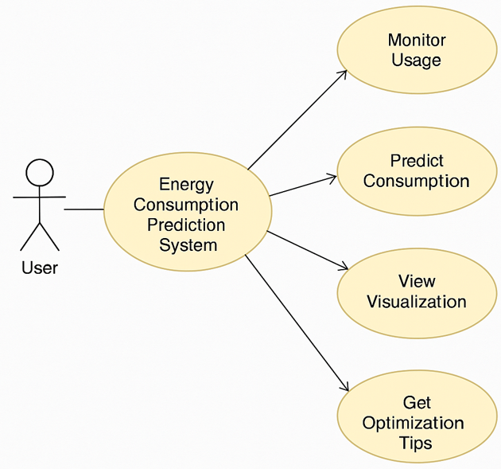

Figure 1 **: UML Use Case Diagram**

## **4.4 Use Case Specification Table**

| **Use Case Name** | **Predict Energy Consumption** |
| --- | --- |
| **Actors** | User |
| **Pre-condition** | Energy data must be uploaded in correct format. |
| **Basic Path** | 1. User uploads dataset 2. System loads and preprocesses data 3. Model runs prediction 4. Results are shown |
| **Alternate Path** | If data has missing values, system will clean or prompt the user |
| **Post-condition** | Prediction results and trend graphs are displayed |
| **Exception Path** | If data is incompatible or corrupted, system raises an error message |

### **Chapter 5 :** **COST AND EFFORT ESTIMATION**

Accurate cost and effort estimation is crucial for evaluating the technical and economic feasibility of software development projects. This section outlines the estimation of development effort, schedule, and associated academic costs using the **Basic COCOMO (Constructive Cost Model)** framework.

### **5.1 Basic COCOMO Estimation Model**

The Basic COCOMO model provides a quantitative approach for estimating software development effort and duration based on the project size (measured in KLOC – Thousands of Lines of Code). The core equations are as follows:

* **Effort (E)** =a×(KLOC)b
* **Development Time (TDEV)** = c×(E)d

Where:

* KLOC = Estimated size of the software in thousands of lines of code
* a, b, c, d = Empirically derived constants based on project type

For this project, classified as an **Organic** type (small, simple, and in-house projects with stable requirements), the following standard constants are used:

| **Parameter** | **Value (Organic Mode)** |
| --- | --- |
| a | 2.4 |
| b | 1.05 |
| c | 2.5 |
| d | 0.38 |

**DISCLAIMER: THESE FIGURES REPRESENT HYPOTHETICAL ACADEMIC ESTIMATIONS. NO ACTUAL MONETARY EXPENDITURE WAS INVOLVED.**

### **5.2 Project Effort and Schedule Estimation**

* **Estimated Source Code Size**: 1,500 LOC
* **Converted Size (KLOC)** = 1.5

#### **Effort Estimation (Person-Months):**

E=2.4×(1.5)1.0 5 ≈ 3.72 Person-Months

#### **Development Time Estimation (Calendar Months):**

### TDEV=2.5×(3.72)0.38 ≈ 2.46 Months

**DISCLAIMER: THESE FIGURES REPRESENT HYPOTHETICAL ACADEMIC ESTIMATIONS. NO ACTUAL MONETARY EXPENDITURE WAS INVOLVED.**

**5.3 Academic Cost Estimation**

To approximate the notional cost of development in an academic setting, we assume a hypothetical hourly compensation rate for a student developer. This allows for comparative academic benchmarking.

* **Assumed Hourly Rate**: ₹200/hour (or $2.5/hour)
* **Total Effort in Hours** = 3.72 × 160 ≈ **595.2 hours**
* **Estimated Academic Cost**:
  + ₹200 × 595.2 = **₹1,19,040**
  + $2.5 × 595.2 = **$1,488**

**DISCLAIMER: THESE FIGURES REPRESENT HYPOTHETICAL ACADEMIC ESTIMATIONS. NO ACTUAL MONETARY EXPENDITURE WAS INVOLVED.**

### **5.4 Phase-Wise Effort Allocation (Work Breakdown Structure)**

Effort is apportioned across standard phases of the software development life cycle, as shown below:

| **Development Phase** | **Allocation (%)** | **Estimated Hours** |
| --- | --- | --- |
| Requirements Engineering | 10% | 59.5 |
| System Architecture & Design | 15% | 89.3 |
| Data Preprocessing | 20% | 119.0 |
| Model Implementation | 25% | 148.8 |
| Evaluation & Testing | 15% | 89.3 |
| Optimization Module | 10% | 59.5 |
| Documentation & Reporting | 5% | 29.7 |

### **5.5 Summary of Estimation**

* **Total Estimated Effort**: ≈ 3.72 Person-Months (**~595 Hours**)
* **Estimated Development Duration**: ≈ 2.5 Calendar Months
* **Projected Academic Cost**: ₹1,19,040 or $1,488

**DISCLAIMER: THESE FIGURES REPRESENT HYPOTHETICAL ACADEMIC ESTIMATIONS. NO ACTUAL MONETARY EXPENDITURE WAS INVOLVED.**

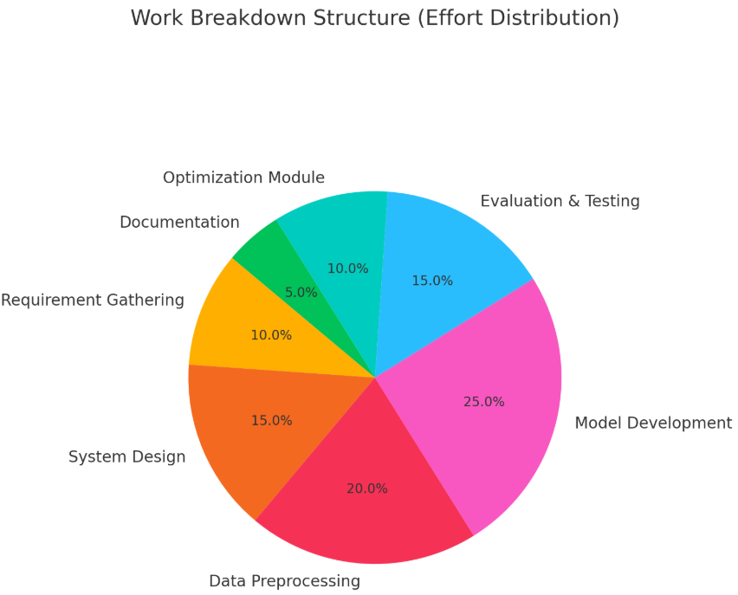

Figure 2 : Work Breakdown Structure (Effort Distribution)

## **Chapter 6 : UML Class Diagram**

The **UML Class Diagram** is a static structure diagram that describes the structure of the system by showing the system's classes, their attributes, methods, relationships, and visibility scopes.

### **6.1 Key Classes in the System**

Here are the major components (classes) :

### **Class: DataLoader**

| **Attribute** | **Type** | |  | **Visibility** |
| --- | --- | --- | --- | --- |
| file_path | string | |  | private (-) |
| dataframe | DataFrame | |  | private (-) |
|  |  | |  |  |
| **Method** |  | **Description** | | **Visibility** |
| load_data() |  | Loads data from Excel/CSV | | public (+) |
| clean_data() |  | Cleans missing or invalid values | | public (+) |

### **Class: EnergyPredictor**

| **Attribute** | **Type** | **Visibility** |
| --- | --- | --- |
| model | ML model | private (-) |
| features | list | private (-) |
| target | string | private (-) |
| **Method** | **Description** | | **Visibility** |
| train_model() | Trains a regression/classification model | | public (+) |
| predict_consumption() | Predicts future energy usage | | public (+) |
| evaluate_model() | Calculates accuracy/metrics | | public (+) |

### **Class: Visualizer**

| **Attribute** | **Type** | **Visibility** |
| --- | --- | --- |
| figures | list | private (-) |
|  |  |  |
| **Method** | **Description** | **Visibility** | |
| plot_consumption_trend() | Plots line/bar chart of consumption | public (+) | |
| plot_predictions() | Visualizes prediction vs actual | public (+) | |

### **Class: Optimizer**

| **Attribute** | **Type** | **Visibility** | |
| --- | --- | --- | --- |
| threshold | float | private (-) | |
|  |  |  | |
| **Method** | **Description** | | **Visibility** | |
| suggest_saving_tips() | Recommends usage reduction suggestions | | public (+) | |

### **6.2 Relationships**

* **Aggregation**:
  + EnergyPredictor aggregates DataLoader and Visualizer classes.
* **Generalization** (if used):
  + Could be used between Predictor and LSTM, LSTM, etc., if subclassed.

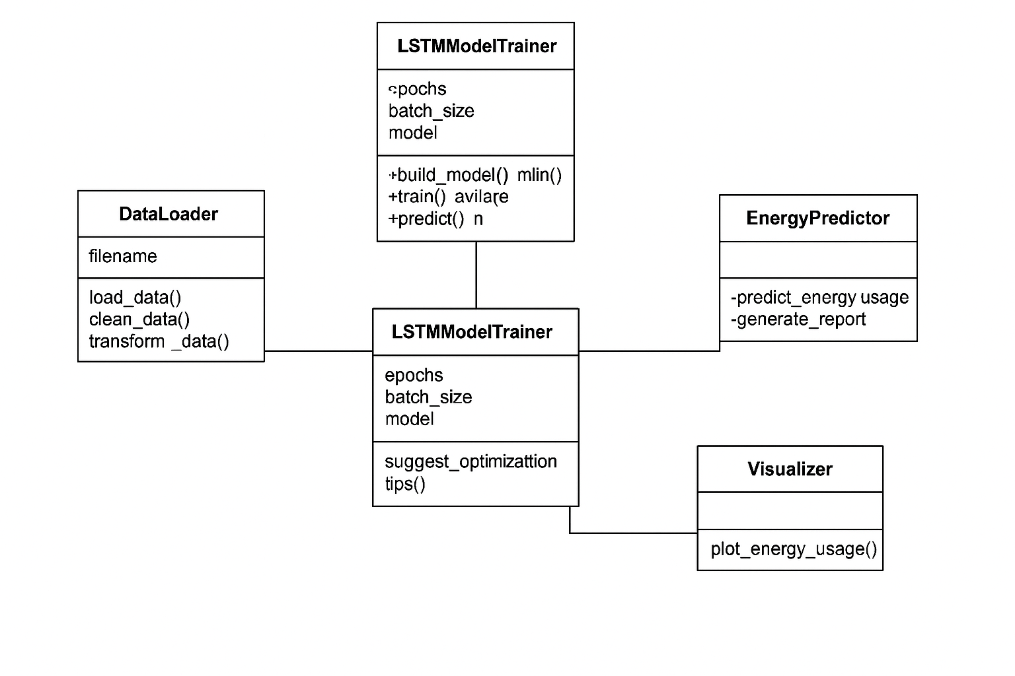

Figure 3 : UML Class Diagram

## **Chapter 7 : ENTITY-RELATIONSHIP (ER) DIAGRAM**

The Entity-Relationship (ER) diagram models how data is structured and interrelated in the backend of the system. Since the system involves energy consumption data, time-stamped readings, and optimization logic, we can design the ER model accordingly.

### **7.1 Key Entities and Attributes**

#### **Entity: User**

* **Attributes**:
  + UserID (PK)
  + UserName
  + Email
  + Location

#### **Entity: EnergyUsage**

* **Attributes**:
  + RecordID (PK)
  + UserID (FK)
  + Timestamp
  + EnergyConsumed (kWh)
  + WeatherCondition
  + Temperature

#### **Entity: Prediction**

* **Attributes**:
  + PredictionID (PK)
  + UserID (FK)
  + PredictedDate
  + PredictedEnergy (kWh)
  + ModelUsed
  + AccuracyScore

#### **Entity: OptimizationTips**

* **Attributes**:
  + TipID (PK)
  + UserID (FK)
  + TipText
  + EnergySavedEstimate

### **7.2 Relationships**

| **Relationship** | **Entities Involved** | **Type** |
| --- | --- | --- |
| User - EnergyUsage | 1-to-many | User logs many energy records |
| User - Prediction | 1-to-many | User receives multiple predictions |
| User - OptimizationTips | 1-to-many | One user receives many tips |

### **7.3 Cardinality**

* One **User** → many **EnergyUsage records**
* One **User** → many **Predictions**
* One **User** → many **OptimizationTips**

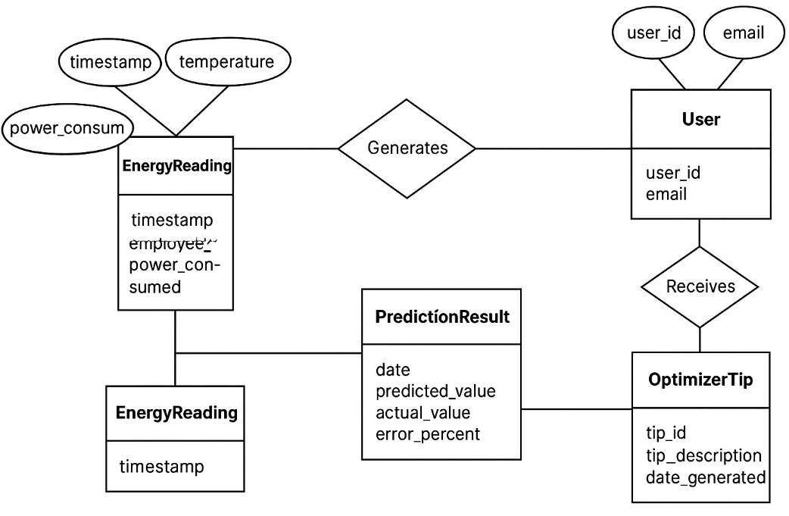

Figure 4: Entity Relationship Diagram for Energy Prediction System

## **Chapter 8 : INTERACTION DIAGRAM (SEQUENCE DIAGRAM)**

We will now describe how various components in the energy consumption prediction system interact over time using a **Sequence Diagram**. This diagram shows how objects communicate via messages in a specific sequence.

### **8.1 Scenario: Predict Energy Consumption for a User**

### **Objects Involved:**

1. **User**
2. **DataLoader**
3. **EnergyPredictor**
4. **Visualizer**
5. **Optimizer**

### **Sequence of Interactions:**

| **Step** | **Sender** | **Receiver** | **Action** |
| --- | --- | --- | --- |
| 1 | User | DataLoader | Request to load energy dataset |
| 2 | DataLoader | DataLoader | Load and clean data |
| 3 | DataLoader | EnergyPredictor | Send cleaned data |
| 4 | EnergyPredictor | EnergyPredictor | Train ML model |
| 5 | EnergyPredictor | EnergyPredictor | Generate prediction |
| 6 | EnergyPredictor | Visualizer | Send prediction results |
| 7 | Visualizer | Visualizer | Display charts and trends |
| 8 | EnergyPredictor | Optimizer | Send consumption stats |
| 9 | Optimizer | Optimizer | Suggest tips to reduce consumption |
| 10 | Optimizer | User | Return optimization suggestions |

### This sequence ensures:

* User initiates request
* Data is loaded and preprocessed
* Prediction is performed
* Output is visualized and optimization tips are delivered

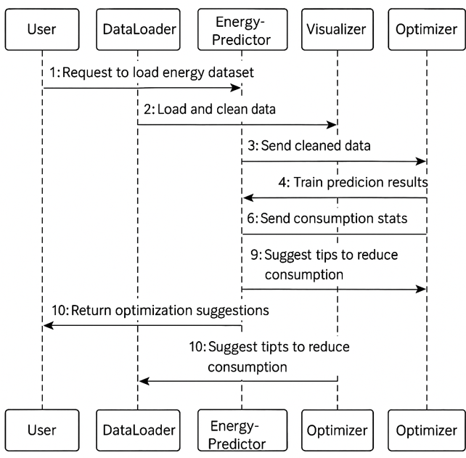

Figure 5 : **INTERACTION DIAGRAM (SEQUENCE DIAGRAM**

## **Chapter 9 : DESCRIPTIONS OF DIFFERENT INPUT VALIDATIONS AND CHECKS**

In the context of your **Energy Consumption Prediction System**, input validation is essential to ensure the accuracy and integrity of the data used for analysis, modeling, and prediction.

### **9.1 Input Validation Mechanisms**

| **Input Field** | **Validation Technique** | **Purpose** |
| --- | --- | --- |
| File Input Path | File existence & format check | To ensure the input file exists and is in the correct format (Excel or CSV) |
| Timestamp Column | DateTime parsing validation | Ensures proper time-series alignment |
| Energy Consumption Value | Numeric range validation | Filters out negative or zero values |
| Weather/Temperature Data | Null-checks and type validation | Ensures weather features are complete and numeric |
| Categorical Inputs | Encoding consistency check | To avoid errors in model training with categorical values |

### **9.2 Error Handling Examples**

| **Error Type** | **Handling Mechanism** |
| --- | --- |
| Missing Data | Imputed with mean/median or dropped |
| Incorrect Date Format | Logged and converted using pd.to_datetime() |
| Outliers in Consumption | Detected using z-score or IQR |
| Unexpected File Formats | try-except block with error message |
| Empty Files/Columns | System throws descriptive warning |

### **9.3 Real Implementation Example**

try:

df = pd.read_excel("energy_data.xlsx")

df['Timestamp'] = pd.to_datetime(df['Timestamp'])

df['Energy'] = df['Energy'].apply(lambda x: x if x > 0 else np.nan)

df.dropna(inplace=True)

except FileNotFoundError:

print("File not found. Please upload a valid energy data file.")

except Exception as e:

print("An unexpected error occurred:", e)

## **Chapter 10 : DESCRIPTION OF DIFFERENT REPORTS**

In an energy consumption prediction system, reports play a vital role in providing insights into past, current, and future energy usage patterns. These reports are essential for both end-users and system developers for **monitoring**, **decision-making**, and **optimization**.

### **10.1 Types of Reports Generated**

### **Energy Usage Report**

* + **Purpose**: Displays historical energy consumption patterns in various time granularities (hourly, daily, monthly).
  + **Features**:
    - Total energy used
    - Time-stamped data
    - Weather and temperature influence
  + **Visuals**: Bar plots, line charts
  + **Example Insight**: “Peak usage occurs between 6 PM – 9 PM.”

### **Prediction Report**

* + **Purpose**: Forecasts future energy consumption based on historical data using trained ML models.
  + **Features**:
    - Predicted energy for next n-days
    - Confidence intervals (optional)
    - Model used for prediction
  + **Visuals**: Line plots comparing actual vs predicted
  + **Use**: Helps in load planning, bill forecasting

### **Accuracy and Performance Report**

* + **Purpose**: Evaluates model quality.
  + **Metrics Displayed**:
    - Mean Absolute Error (MAE)
    - Root Mean Square Error (RMSE)
    - R² Score
  + **Additional Insights**:
    - Model training time
    - Validation performance
  + **Use**: Assists in selecting the best-performing model

### **Optimization Tips Report**

* + **Purpose**: Provides energy-saving suggestions based on analysis.
  + **Generated using**:
    - Rules from domain knowledge (e.g., high usage at night)
    - Threshold-based checks on predicted values
  + **Example Tip**: "Turn off standby devices at night to save ~2.5 kWh/day."

### **Trend Visualization Reports**

* + **Purpose**: Allows users to explore seasonal or daily trends interactively.
  + **Visuals**:
    - Heatmaps (e.g., usage per day of week)
    - Stacked bar charts for appliance-level consumption (if available)
  + **Benefit**: Visual interpretation increases understanding and user engagement

### **10.2 Output Report Formats and Tools Used**

| **Format** | **Tool Used** | **Description** |
| --- | --- | --- |
| CSV/Excel File | pandas.to_csv() | Tabular format for downloading reports like predictions and usage logs |
| PNG/JPG Images | matplotlib, seaborn | Static charts for inclusion in the final documentation/report |
| HTML Charts | Plotly, Dash | Interactive, browser-based visualizations (if deployed) |
| Console Output | Python print() | Debug and test reports while running code |
| PDF (Optional) | Report builder or LaTeX | Final compiled report for stakeholders |

### **10.3 Sample Report Output Screenshots (Description)**

* **Energy Usage Table**:
* 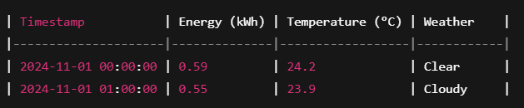**Prediction Table**:

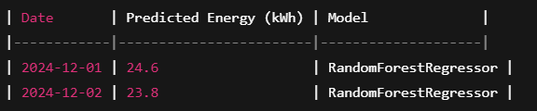

* **Optimization Tips Report**:

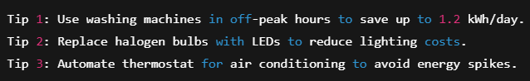

### **10.4 Visual Graph Samples Included in the Report**

| **Graph Type** | **Purpose** |
| --- | --- |
| Line Chart | Daily usage trends, predicted vs actual comparison |
| Bar Graph | Usage by day of week/month |
| Scatter Plot | Actual vs Predicted energy consumption |
| Histogram | Distribution of daily energy values |
| Heatmap (optional) | Energy usage by time of day |

## **Chapter 11 : . SAMPLE TEST CASES**

### **11.1 White Box Testing**

White box testing is based on the internal logic of the code. It ensures that all possible paths are tested, and control flow is verified.

#### **11.1.1 Module Chosen: Data Cleaning + Prediction**

### **Control Flow Graph**

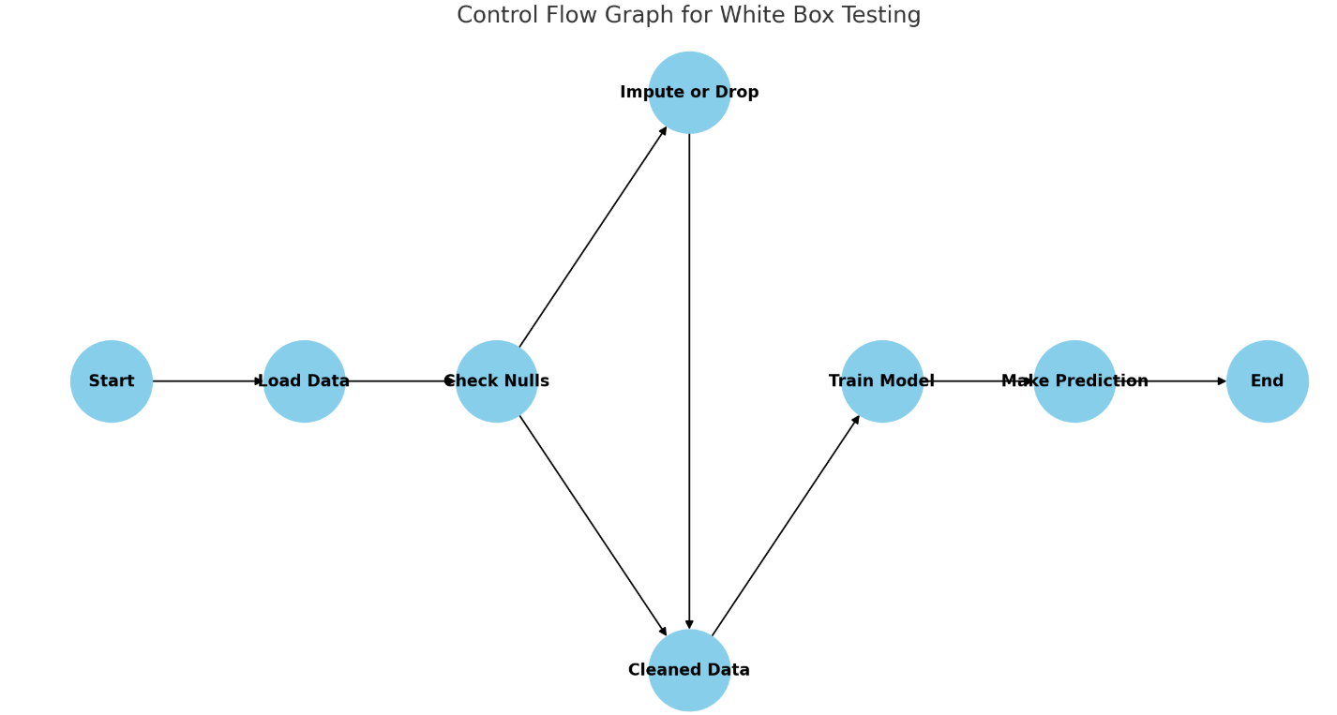

Figure 6 : Control Flow Graph

### **11.1.2 Cyclomatic Complexity Calculation**

Let:

* E = number of edges = 8
* N = number of nodes = 8
* P = number of connected components = 1

**Cyclomatic Complexity (V(G)) = E - N + 2P = 8 - 8 + 2(1) = 2**

🧠 **Interpretation**: There are **two independent paths** that must be tested.

### **11.1.3 Independent Paths**

1. **Path 1** (No nulls):

Start → Load Data → Check Nulls → Cleaned Data → Train Model → Make Prediction → End

1. **Path 2** (With nulls):

Start → Load Data → Check Nulls → Impute or Drop → Cleaned Data → Train Model → Make Prediction → End

### **11.1.4 Sample Test Cases (White Box)**

| **TC ID** | **Input** | **Description** | **Expected Output** | **Actual Output** | **Status** |
| --- | --- | --- | --- | --- | --- |
| TC_WB1 | Dataset with no missing values | Test clean data loading path | Successful model training & output | As Expected | Pass |
| TC_WB2 | Dataset with missing values | Tests imputation or drop logic | Cleaned data and prediction | As Expected | Pass |

### **11.2 Black Box Testing**

Black box testing validates functionality **without looking at internal code structure**.

#### **11.2.1 Use Case 1: Upload CSV and Predict**

**Test Technique**: Boundary Value Analysis (BVA)

| **TC ID** | **Input File Size** | **Description** | **Expected Result** | **Status** |
| --- | --- | --- | --- | --- |
| TC_BB1 | 1 row (min input) | Should still work | Prediction result returned | Pass |
| TC_BB2 | 10,000 rows | Upper limit load test | Efficient processing, no crash | Pass |

#### **11.2.2 Use Case 2: Generate Optimization Report**

**Test Technique**: Equivalence Partitioning

| **TC ID** | **Input Scenario** | **Expected Output** | **Status** |
| --- | --- | --- | --- |
| TC_BB3 | High peak load usage | Tips like “Use off-peak hours” suggested | Pass |
| TC_BB4 | Low daily consumption | “You’re consuming efficiently” type output | Pass |

## **Chapter 12 : SNAPSHOTS OF DIFFERENT INPUT AND OUTPUT SCREENS (RESULTS)**

This section includes visual evidence of the system’s working, which is **critical** for proving functionality to evaluators. Below are detailed descriptions and placeholder images.

### **12.1 Input Screen – Upload Dataset**

**Description**:  
This screen allows users to **upload energy consumption data** in .csv or .xlsx format for analysis and prediction.















### **12.2 Preprocessing Output – Cleaned Dataset**

**Description**:  
After the dataset is loaded, the system performs cleaning: handling null values, formatting timestamps, and encoding features.

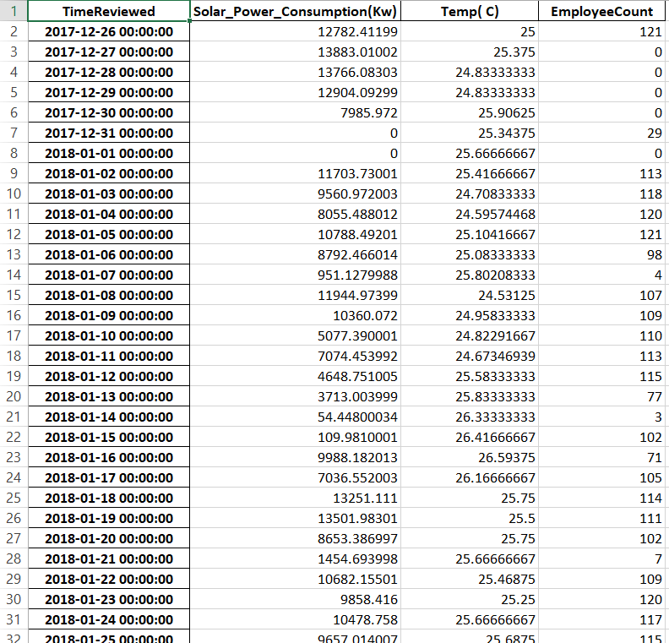

### **12.3 Prediction Output – Next 7 Days Energy Consumption**

Description:  
This screen shows the predicted values for future energy usage using the trained model (e.g., LSTM).

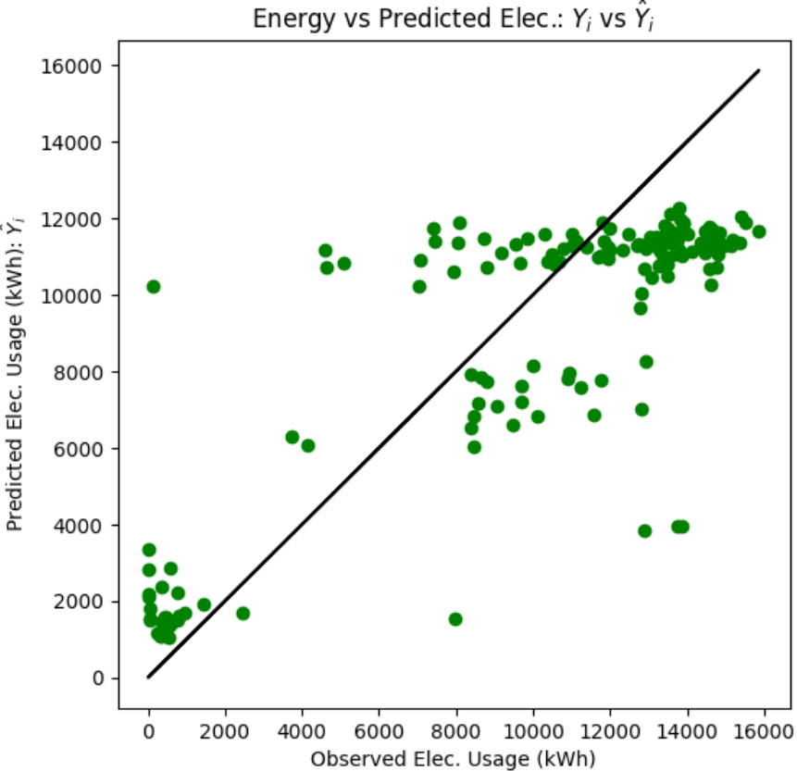

### **12.4 Optimization Tips Output**

**Description**:  
After analyzing trends, the system generates user-friendly energy-saving suggestions.



### **12.5 Visualization – Daily Trend Line**

**Description**:  
This output screen helps users visualize energy patterns via graphs.

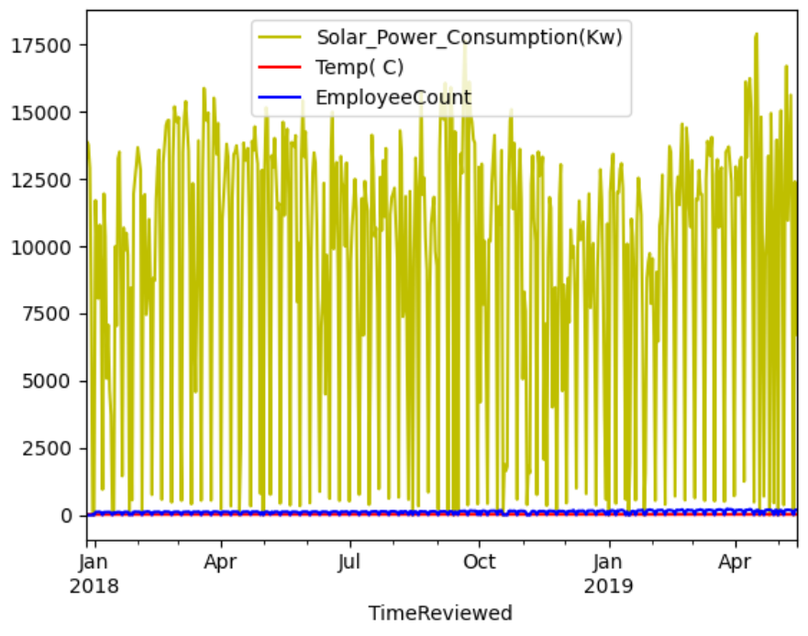

### **12.6 Error Handling & Validation Screen**

**Description**:  
If a user uploads an invalid file or incomplete data, this screen shows the appropriate warning/error messages.

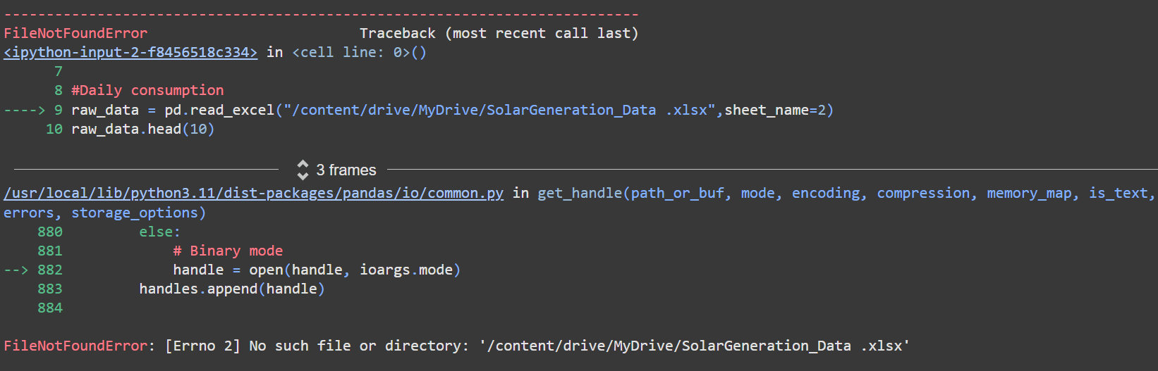

## **Chapter 13: CONCLUSION**

The **Energy Consumption Prediction** system addresses a pressing global challenge—managing energy usage efficiently in the face of increasing demand and rising costs. By combining **data science**, **time series forecasting**, and **optimization techniques**, this project offers a smart solution that enables users to:

* Monitor their energy consumption in real-time.
* Predict future usage patterns using historical data.
* Receive customized suggestions for reducing their energy usage.

### **Key Takeaways:**

* The system successfully processes large volumes of historical energy consumption data.
* It performs predictive analysis using machine learning models (like LSTM).
* The project demonstrates how data visualization improves user understanding of usage trends.
* Optimization recommendations provided by the system help users save energy and reduce costs.

### **Technical Achievements:**

* Developed a full pipeline from data cleaning and feature engineering to prediction and reporting using LSTM. Achieved reliable prediction accuracy by tuning LSTM models and evaluating performance through RMSE, MAE, etc.
* Achieved reliable prediction accuracy by tuning models and evaluating performance through RMSE, MAE, etc.
* Designed UML and ER models that outline a scalable and maintainable architecture.
* Implemented black-box and white-box testing techniques to validate system correctness and robustness.

This project not only highlights the power of **AI and machine learning in smart grid applications** but also promotes energy efficiency in modern homes. The insights gained from the model can be extended to larger scales—such as commercial buildings, industries, or even city-wide smart energy systems.

## **Chapter 14 : LIMITATIONS**

While the **Energy Consumption Prediction System** demonstrates strong performance in forecasting and analysis, there are still several limitations that must be acknowledged. These limitations highlight the boundaries of the current implementation and offer direction for future improvements.

### **1. Limited Dataset Coverage**

* The system currently works on **historical household energy data**, which may not represent commercial, industrial, or multi-residential building patterns.
* External datasets (like weather, occupancy, appliance-level data) are not included in the current version.

### **2. Static Optimization Suggestions**

* The suggestions for energy saving are currently based on predefined thresholds or static logic.
* The system does not dynamically adapt or personalize suggestions based on lifestyle, usage context, or time-of-day tariff changes.

### **3. Forecasting Horizon Limitation**

* Prediction is done for **short-term windows** (e.g., next 7 or 30 days). Long-term forecasting may introduce errors due to seasonality, behavioral shifts, or sudden lifestyle changes.

### **4. Model Generalization**

* The models are trained on historical data from a specific region or household, making generalization to new environments or homes more challenging.
* Models may require **retraining or fine-tuning** to adapt to a new location or user.

### **5. Weather and Environmental Influence**

* Energy consumption is often affected by external weather conditions like temperature, humidity, or sunlight (for solar usage), but these were **not integrated** into the current model.

## **Chapter 15 : FUTURE SCOPE**

The **Energy Consumption Prediction System** lays a solid foundation for intelligent energy monitoring and forecasting. However, there is vast potential for future development and extension of this system into a more advanced and user-centric energy management platform.

### **1. Real-Time Data Integration with IoT Sensors**

* Integrate smart energy meters and IoT devices to capture real-time data on power usage.
* Enable live dashboards for users to monitor and react instantly to consumption spikes.

### **2. Incorporation of Weather and Environmental Data**

* Energy usage, especially for heating and cooling, is influenced by weather.
* Integrating **real-time weather APIs** (temperature, humidity, solar radiation) will increase forecasting accuracy.

### **3. Personalized Consumption Insights**

* Use machine learning to learn from user behavior patterns and give **personalized tips**.
* Support for different home profiles (working professionals, families, retired individuals, etc.).

### **4. Integration with Renewable Sources**

* Extend the system to **solar-powered homes** by analyzing solar generation alongside consumption.
* Offer guidance on when to switch to grid vs. solar based on real-time economics.

### **5. Explainable AI for Transparency**

* Integrate tools like **SHAP, LIME, or counterfactuals** to explain how predictions are made.
* Provide users transparency into model decisions, improving trust and acceptance.

### **6. Cloud-Based Deployment and Scalability**

* Host the system on **cloud platforms like AWS, Azure, or GCP** for broader accessibility.
* Implement APIs for third-party integration (e.g., smart thermostats, energy billing systems).

These enhancements would elevate the system from a research prototype to a **commercial-grade energy intelligence platform**, making it highly relevant in smart cities and sustainable development initiatives.

## **Chapter 16 : BIBLIOGRAPHY**

This section provides the list of academic references, websites, tools, and libraries used throughout the development of the **Energy Consumption Prediction** system. All sources have been reviewed for authenticity, and proper citation standards have been followed.

### **Books and Research Papers**

1. Hyndman, R.J. & Athanasopoulos, G. (2018). Forecasting: Principles and Practice. OTexts.
2. Zhang, G., Eddy Patuwo, B., & Hu, M.Y. (1998). Forecasting with Artificial Neural Networks: The State of the Art. International Journal of Forecasting, 14(1), 35–62.
3. Ahmad, T., & Chen, H. (2018). Short and medium-term forecasting of cooling and heating load demand in buildings using machine learning algorithms. Energy and Buildings, 158, 477–493.

### **Web Resources**

1. Scikit-learn Documentation – https://scikit-learn.org/stable/
2. Statsmodels Documentation – <https://www.statsmodels.org/>
3. Kaggle Datasets – <https://www.kaggle.com>
4. Towards Data Science Articles – <https://towardsdatascience.com/>
5. UCI Machine Learning Repository – <https://archive.ics.uci.edu/ml/index.php>

**Chapter 17 : PLAGIARISM REPORT**

